The Interviews
Joe Grace and Anthony Cooney
(Interviewed in Carrick on Suir, County Tipperary, 13 March 2016 by Tomás Mac Conmara -also present - Norman Storey)

On 13th March 2016, Joe Grace and Anthony Cooney met with the Iverk Show Oral History Project in Carrick on Súir, in the front room of Joe’s home. In the interview, both men spoke about their personal involvement and memories of the Iverk show over many years.
Joe Grace was born in Piltown in 1923 and so was in a position to offer personal memory reaching back to the early 1930s. Joe also reflected on the closure of the show during World War II or the Emergency, as it was known to many Irish people. The show reopened after the war ended in 1945 and Joe spoke warmly about the effort and commitment of local people towards its revival. Interestingly, in the interview, Joe was also emphatic that ‘the real name’ of the show was ‘The Barony Meeting’. In a separate interview, ninety-four-year-old Nan Murphy was equally insistent, that ‘The Piltown Show’ was the only accurate description!
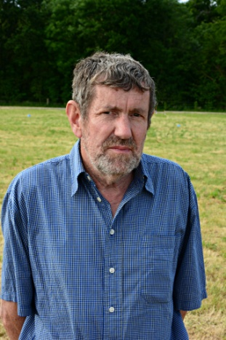
Anthony Cooney explained how his father (James Cooney) was involved in Muntir Na Tíre, the group that helped re-establish the show after World War II. Anthony is a much younger man than Joe but is also steeped in the show’s history. In the interview, he spoke about his own personal memories of the show and in particular, evoked a childhood image of the creamery cart competitions. He also outlines his first direct participation in the show, which surrounded his personal responsibility to put halters on cows and walking them, in preparation for the show.
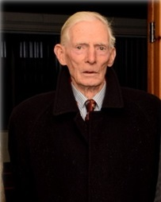
Joe Malone
(Interviewed in Belline, County Kilkenny, 03 March 2016. Interviewed by Tomás Mac Conmara. Also present - Norman Storey)

Joe Malone was interviewed at his family farm in Belline, outside of Piltown. At the time of the interview, Joe was President of the Iverk Show and had been a committee member for over sixty years.
Appropriately, the recording is set against the unavoidable noise of an active farm and so, his cattle and dogs make their contribution to the interview on occasion! In the interview, Joe discusses his family background and farming in Belline, South Kilkenny, the changing nature of agriculture over the years and the economics and politics surrounding farming. Joe also discusses his over six decades’ involvement with the Iverk Show. Born in 1932, Joe emphasised to the interviewer the physical nature of work in his younger life and contrasted this with the work that young people are doing today. Leaning forward, in his kitchen in Belline, Joe declared; 'Twas pure work, work, work, once you were farming'.
Joe’s earliest memories of the Iverk Show date from approximately 1949, when a predominantly fruit show reopened after its cancellation during World War II. Like most interviewees, Joe was deeply aware of the history of the show and credits Lady Bessborough with encouraging her husband to help improve agricultural standards in the area, a move which led to the show’s beginning in 1826.
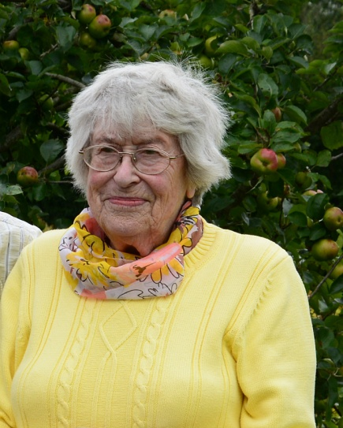
Nan Murphy
(Interviewed in Portlaw, County Waterford, 13thMarch 2016. Interviewed by Tomás Mac Conmara. Also present - Norman Storey)
Nan Murphy was ninety-four years old when interviewed for the ISOHP in March 2016. Remarkably, Nan has been an attendee at the Iverk Show for over 80 years! After being given a warm welcome to her home in Portlaw, the recording started across her living room table, which was decorated for the occasion with several Iverk Show related items. Nan first spoke about her early farming life in Portlaw and describes work on the farm as a child, milking cows by hand, as well as making and selling butter. The farm economy, emigration, schooldays and horses were also explored before a long and remarkable reflection on the Iverk Show unfolded. It is important at this point to underline Nan’s assertion that what is now the Iverk Show, was always known as ‘The Piltown Show’. Similar to the interview with Joe Malone, contributions from Nan’s farm were inevitable, with her cockerel insisting on a contribution to the recording, from time to time. In the interview, Nan speaks about her earliest memories of life in Bealough, Portlaw and proudly states that she is the fourth generation of O'Mahonys who have lived on the farm in Béalough. Sadly, she reveals that she is now the last of the O'Mahony family.
Nan recalls hearing about ‘the Piltown Show’ when she was a child and affirms it was 'the big thing of the year'. She recalls going to the show in 1931, while holding her father's hand and carefully describes her memories of the event, and in particular, the Ponsonbys who were in residence at this time. Nan also affirms that the Iverk Show was always seen as an open event and that county divisions were irrelevant. She brilliantly explains the changing nature of the show in her declaration that ‘now you have tractors that you'd want a ladder to get up to the cockpit!

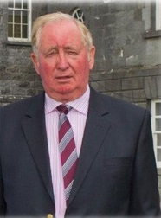
Wattie Walsh
(Interviewed in Tybroughney, County Kilkenny, 3rdMarch 2016. Interviewed by Tomás MacConmara. Also present – Norman Storey)
Wattie Walsh was in his 21st year as Chairman of the Iverk Show when he was interviewed for the project in early March 2016, at his home in Tybroughney. In the interview, Wattie speaks about his family background in South Kilkenny and his childhood in Piltown.
He reflects on growing up in a rural area on a small farm, killing the pig, self-sufficiency, farm work, the Fair of Carrick on Suir, the Economic War, Economics and World War II. He also speaks fondly about his mother, Mary Ellen Walsh, a butter maker from West Cork who married his father Jack in 1938.
Wattie recalls his earliest memories of going to the Iverk Show in the years following World War II (The Emergency). Like Anthony Cooney, Wattie credits Muintir na Tíre with managing to get the show going after the war in Tom Walshe's field in Piltown. He recalls that a man called Willie Heneberry was Secretary before the War but that Gerry O'Donoghue became the key figure after the war as Secretary. Wattie fondly recalls the way that Gerry O'Donoghue managed the finances of the Show committee. He also offers an account of the Iverk Show’s history and the significance of the 190th anniversary (2016). He also reflects on about the 4th Earl of Bessborough, who founded the Iverk Show in 1826.

