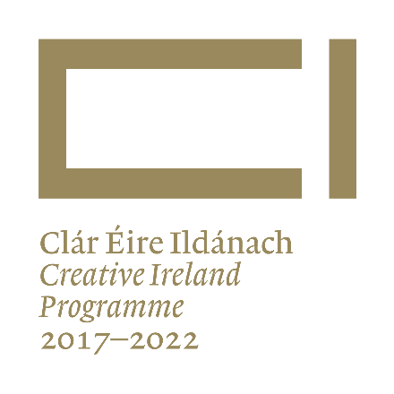
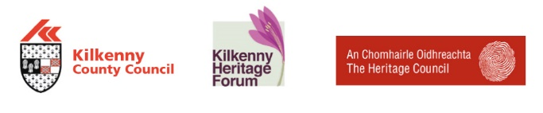

PRESS RELEASE

Major Audit of Oral Heritage Recordings in County Kilkenny underway

“What was my childhood like? Well I wasn't going on any holidays to France or anything like that or to Spain … We had a small farm and we lived away out of it. My mother wasn't local. My mother came to Piltown, a butter maker … We lived off the farm more or less. We killed a pig and we ate him and we had vegetables and potatoes. My mother had chickens and we might eat some of ‘em and we had eggs. We had no electricity, we had no telephone, no car … We had a pony to bring us to mass and to go to the creamery.”

- Wattie Walsh, Tybroughney, recorded for the Iverk Show Oral History Project.

Over many decades in Kilkenny, precious memories of times gone by have been recorded by groups and individuals in an effort to document what are often fading memories of our past. Now, Kilkenny County Council are undertaking a major audit of these collections, to compile a list for the first time of what has been recorded in the county. Do you know of oral heritage recordings made about people, places or topics in County Kilkenny? Perhaps you’ve made recordings yourself? Maybe there are collections of oral history recordings that you know of? If there are, then the Heritage Office of Kilkenny County Council would like to hear from you.

According to Dr. Tomás Mac Conmara, the consultant appointed to lead the audit, the identification of collected material relating to Kilkenny will help encourage the people of the county to engage with their own heritage. He explained that the project is not seeking to physically take collections, but instead is aimed at compiling a detailed list of what has been recorded as well as information about the collections, like their current location, format, content etc.

“The people of Kilkenny are steeped in an oral culture” said Dr. Mac Conmara. “A significant amount of material has been collected over the decades relating to Kilkenny. This can range from the professional work undertaken by the Irish Folklore Commission to a community collection of folk traditions and customs, or a family recording, undertaken to document the memories of a grandmother. The purpose of the audit is to just identify, in so far as possible, what has been collected and to put that information together for the first time in one database”, he said.

Dr. Mac Conmara will be investigating local and national sources to find out the extent and nature of oral history collections for County Kilkenny. This will include local history societies, Kilkenny County Library, Raidió na Gaeltachta, local radio stations as well as regional and national repositories such as the National Folklore Collection, National Archives and the National Library of Ireland. Most importantly, however, the audit will also focus on private collections and the work of various community groups and heritage organisations, who according to Kilkenny Heritage Officer, have been very active in recording our heritage:

“In recent years, Kilkenny Heritage Office has supported a number of oral recording projects. They are such an important part of our cultural heritage”, said Dearbhala Ledwidge, County Kilkenny Heritage Officer. “This audit and database will give us an idea of the recordings that already exist and will help to identify priorities for future recording work. We would really appreciate people’s help in identifying other oral history recordings or collections held by community groups and individuals” she added.

The successful completion of the audit is sure to be a significant resource for historians, scholars, the education system and the general public. If you have any information on oral heritage recordings or collections on County Kilkenny topics, people or places, please contact the Kilkenny Heritage Office, Kilkenny County Council on 056-7794925 or by e-mail at heritage@kilkennycoco.ie. The audit will be completed in mid-September and will be available to the public online. A publication, based on the findings of the audit will also be produced.

“An action of Kilkenny County Council Cultural Strategy 2017-2022. Co-ordinated and funded by the Heritage Office of Kilkenny County Council with funding from the Heritage Council and Creative Ireland”

Press Release Ends

For further information, please contact:

Dearbhala Ledwidge
Heritage Officer,
Kilkenny County Council,
Johns Green House,
Johns Green,
Kilkenny, R95 CX92.
Telephone: 056-7794925
E-mail: Dearbhala.ledwidge@kilkennycoco.ie

