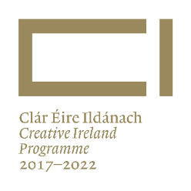
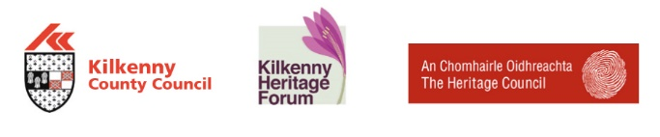

Oral Heritage Collections in Kilkenny – Can You Help?
Do you know of oral heritage recordings made about people, places or topics in County Kilkenny? Perhaps you’ve made recordings yourself? Maybe there are collections of oral history recordings that you know of? If there are, then the Kilkenny Heritage Office of Kilkenny County Council would like to hear from you.

Kilkenny Heritage Office have just announced the commencement of an Audit of Oral Heritage Collections in County Kilkenny. The audit aims to identify recorded collections of oral heritage and folklore that have been undertaken over the decades, in both private and public bodies. The audit will only list collections and will not physically take them. The information gathered will be published online and in an associated booklet.
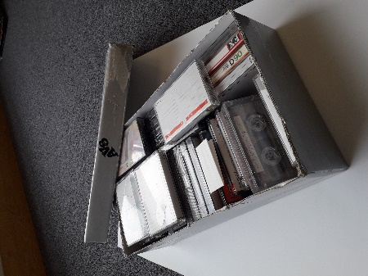
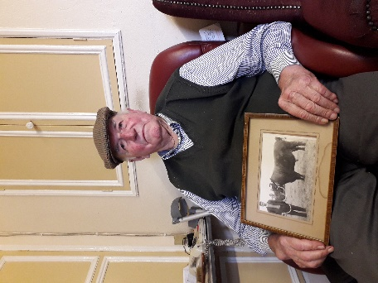

The types of subjects explored in oral heritage collections could include:
- Life stories
- Folklore, customs and folk belief
- Farming/agriculture
- Oral tradition of the Irish revolutionary period
- Influential people (politics, sport, religion, literature, public life)
- Trades of the past/Fishing
- The Economic War, the Emergency (World War II)
- Rural electrification/Social Change
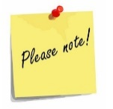
Irrespective of the subject, if you know of a recording or collection relating to life in the past in Kilkenny, we want to hear about it.

If you know of any collections we would be very grateful if you could let fill out the survey overleaf and either post or email it back to the Dearbhala Ledwidge, Heritage Officer, Kilkenny County Council, Johns Green House, Kilkenny. Tel: 056-7794925. Email: heritage@kilkennycoco.ie
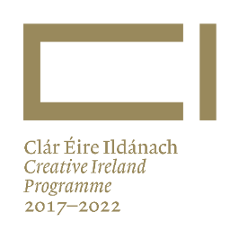

Oral Heritage Collections in Kilkenny – Can You Help?

Current Location of collection and collection holder ……………………………………………………………………………………………………………………………………………………………………………………………………………………………………………………………………………………

Collection description (Broad description of the collection - i.e. 'Related to customs' etc.)
........................................................................................................................................................................................................................................................................................................
History/Further information/Stories associated with the collection
........................................................................................................................................................................................................................................................................................................
Format: (I.e. Mini cassette tapes, CD, digital files etc.) ………………………………………………………

Initial data generation: (Was the material recorded by the current holder or elsewhere?)

............................................................................................................................................
............................................................................................................................................

Size of Collection (Approximately how many recordings are in the collection?) ....................................................................................................................................................
The information above has been kindly supplied by:
Name..........................................................................................................................................
Address......................................................................................................................................
Email..........................................................................................................................................
Tel..............................................................................................................................................
Thank you for taking the time to fill out this survey.
A member of the audit team may be in contact for further information or clarification.

“An action of Kilkenny County Council Cultural Strategy 2017-2022. Co-ordinated and funded by the Heritage Office of Kilkenny County Council with funding from the Heritage Council and Creative Ireland”

