2018 Kilkenny Creative Ireland Programme
Twenty cultural initiatives received funding from the Kilkenny Creative Ireland Programme in 2018.
Cruinniú na nÓg (National Day of Creativity for Young People 23rd June 2018)
- Children’s Cultural Workshops (Kilkenny County Library Service) http://www.kilkennylibrary.ie/eng/Whats_On/Criunniu-na-nOg-Kilkenny-Programme.pdf
- Children’s Theatre Workshops(Barnstorm Theatre Company)
- Mini Craft Village (Design & Craft Council of Ireland) https://www.craftinireland.com/events/details/craft-village-for-cruinniu-na-n0g
Decade of Centenaries
A programme of commemoration relating to the significant events in Irish history that took place between 1912 and 1922.
- Lá na mBan (Kilkenny Archaeological Society project to find the Kilkenny women who opposed conscription in 1918 and tell their stories) Further information at http://kilkennyarchaeologicalsociety.ie/library/la-na-mban-project/
Creative Ireland
- Bookville: Children’s Book Festival http://www.bookvillekilkenny.com/
- Reader in Residence: Christmas memory initiative as part of Yulefest
- Whispering Fields: A short film about field names in County Kilkenny
- Children’s cultural workshops: Fairy Tale Festival, Woodstock Gardens http://www.kkccc.ie/2018/07/04/childrens-fairytale-festival/
- Rhyme Rag Ensemble: Publication from youth poetry group
- County Kilkenny Oral Heritage Audit. http://kilkennyheritage.ie/2018/06/can-you-help-us-with-kilkennys-oral-heritage-audit/
- Stories from Waterways: A short film about the River Barrow
- Bealtaine: Festival for Older People https://www.kilkennycoco.ie/eng/Publications/Council_News/Bealtaine-Brochure-2018.pdf
- Mórbhileog Chill Chainnigh: Literary Broadsheet as gaeilge
- The Big Chapel: One County, One Book workshops http://www.kilkennylibrary.ie/eng/Whats_On/One-County-One-Book-The-Big-Chapel-2018.html
- The Breadwinner Exhibition: Interactive multimedia collaborative exhibition between Cartoon Saloon and the Butler Gallery http://www.butlergallery.com/the-breadwinner-exhibition/
- Bring Your Own Chair: Artist residency looking to reclaim public space in rural towns and villages across counties Kilkenny, Wexford and Waterford https://callanworkhouseunion.com/project/bring-your-own-chair/
- Mná na hÉireann – 1918-2018: Lectures and presentations on the changing lives and roles of Mná na hÉireann in the early years of the 20th century
- Citizen Science Biodiversity Programme: Recording Kilkenny’s Biodiversity
- Cultural Fringe at Graiguenamanagh Town of Books https://www.facebook.com/IrelandsBooktown/

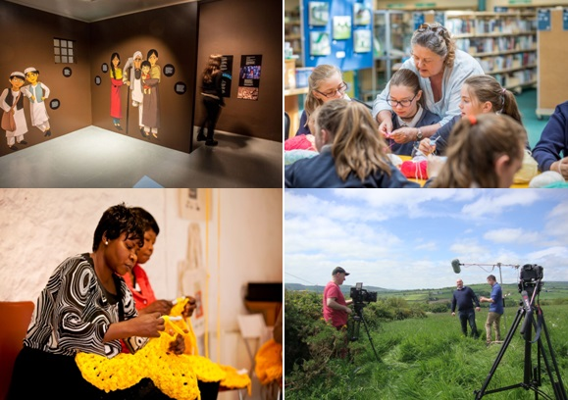
A selection of photos from Creative Ireland funded events in Kilkenny
To find out more about the Kilkenny Creative Ireland events go to https://creative.ireland.ie/en/events?county=25

