25th February 2020

Dear Principal
Free “Heritage in Schools” visits for Kilkenny Primary Schools
Following the success of last year’s free “Heritage in Schools” visits for Kilkenny primary schools the Heritage Office of Kilkenny County Council, in partnership with the Heritage Council, is delighted to invite you to avail of the free visits again in 2020.
Last year 55 primary schools in the county (i.e. over 70% of schools) took part in the programme and the feedback from the schools was fantastic. We’d like to reach even more schools this year, and we are also introducing a new themed approach – all visits must focus on biodiversity and pollinators.
The Heritage in Schools Scheme is a heritage education programme, developed and coordinated by the Heritage Council, which provides Garda vetted heritage specialists to visit primary schools to teach children about heritage.
Normally the cost of the visits is paid for jointly by the Heritage Council and the primary school. However, in order to make this unique resource available to more children in Kilkenny, the Heritage Office of Kilkenny County Council will cover the schools portion of the cost with funding kindly given to us by Creative Ireland. The Heritage Council will continue to pay half the costs. So there is no cost to the school for a 1 day visit from a heritage expert.
The scheme is a fantastic educational resource for your school; it supports the aims of the Social Environmental Scientific and Education (SESE) curriculum; it provides an opportunity to incorporate creativity into the heritage learning experience; it is of particular value to any schools taking part in the Green Schools “Biodiversity” Theme.
See attached for details of how the scheme will work. For further information on the Heritage in Schools Scheme and the range of experts on the panel, see http://www.heritageinschools.ie/
To avail of this offer please fill in the attached form to register your interest, and email it to heritage@kilkennycoco.ie before March 6th. Please put “Heritage in Schools Offer” in the email subject line.
The Heritage in Schools visit must be completed, including reporting, by Friday 3rd October 2020.
If you have any queries please contact Bernadette Roberts at Bernadette.roberts@kilkennycoco.ie , Telephone No: 056-7794938
Yours sincerely
Dearbhala Ledwidge
Dearbhala Ledwidge
Heritage Officer
Kilkenny County Council

Encls: How the free “Heritage in Schools” Programme works
Expression of Interest Form

How the free “Heritage in Schools” Programme works

What lesson topics can be covered in the Free Heritage in Schools visits in Kilkenny?
- The topics of the free visits must support the SESE curriculum
- Lessons must relate to Kilkenny’s biodiversity and pollinators
- Lessons must include a creative element
- Consider including an outdoor element in the visit
What if your school wants the visits to focus on other aspects of heritage, e.g. history or cultural heritage?
- Schools are welcome to avail of the standard Heritage in Schools programme, whereby the Heritage Council pays 50% of the costs, and the schools pay 50%. This is still great value for the school. However, to avail of the free visits, provided by Kilkenny County Council Heritage Office, you must agree to focus on biodiversity and pollinators. The reason we have introduced this condition is that with the current global climate change and biodiversity emergencies, Kilkenny County Council is prioritising actions to help support Kilkenny’s Biodiversity and Pollinators.
Step by Step Guide to how the scheme will work
- Obtain approval for the visit from the School Principal or Board of Management.
- Email the completed “Expression of Interest Application Form” to the Heritage Office of Kilkenny County Council at heritage@kilkennycoco.ie before March 6th. Please include “Heritage in Schools Offer” in the email subject line, and include the school roll number in the application form.
- A confirmation email to acknowledge receipt of your application will be sent to you from the Kilkenny County Council Heritage Office, along with a list of the Heritage Experts who are available to deliver the programme in Kilkenny.
- We will then forward your details to the national “Heritage in Schools” Co-ordinator.
- You are advised to review all the terms and conditions of the scheme before proceeding to the next step. http://www.heritageinschools.ie/
- Each school must then contact the Heritage Expert whom they wish to book, in order to plan the visit, arrange the date, time and duration. Please note that the visit topic must relate to Kilkenny’s biodiversity and pollinators, and must include a creative element.
- Each school must then register the booking on the Heritage in Schools online booking system http://www.heritageinschools.ie/heritage-expert/book-an-expert. There will be a question “Is this visit fully funded?” on the online form. Please click “Yes”, and then choose the “Kilkenny CoCo – Creative Ireland” option from the drop-down menu. Failure to book in advance will result in the visit not being paid for.
- Once the visit has been completed the school will be emailed a simple evaluation form (survey monkey) which must be completed.
- The Heritage Expert will then invoice the Heritage Council for 50% of the cost, plus expenses; and the Heritage Office for 50% of the cost. The Expert is also required to send in a brief evaluation report to the Heritage Council and Kilkenny County Council Heritage Office.
Please note that bookings can only be made for workshops in 2020, and that the visit must be completed and all paperwork submitted before Friday 3rd Oct 2020.
Full details of all the terms and conditions of the Heritage in Schools scheme are available at http://www.heritageinschools.ie/

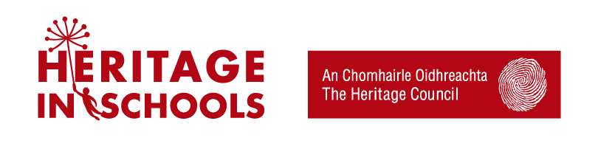
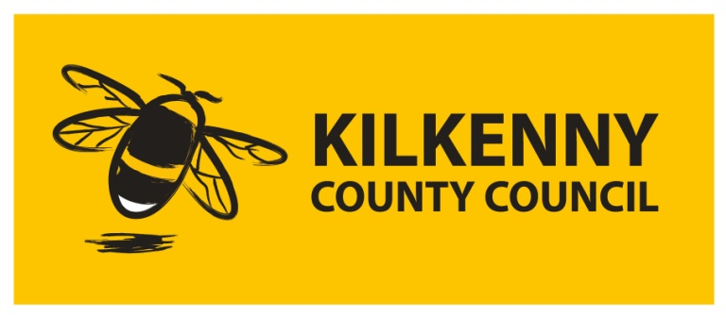
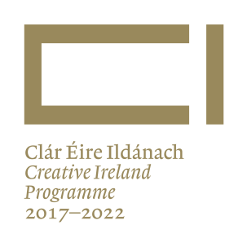
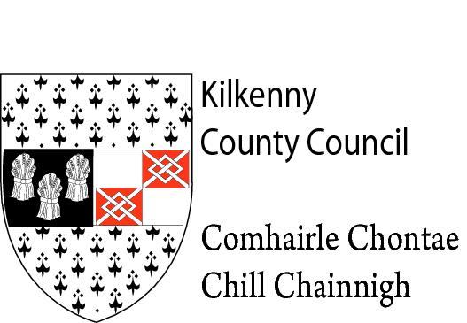

Kilkenny County Council Heritage Office
Free Heritage in Schools Visits for Kilkenny Schools 2020
Expression of Interest Application Form – Please complete in block letters
Name of School...........................................................................Roll No………………………
Address..............................................................................................................................
School Email Address………………………………………………………………………………………………..
Name of Applicant.............................................................................................................
Position in School..............................................................................................................
Please note that the visit topic must relate to Kilkenny’s biodiversity and pollinators, and must include a creative element.
Our school wishes to avail of the free Heritage in Schools visits, and agrees to the conditions of the scheme. We give consent for our application to be shared with the Heritage Council.

______________________________ ___________________
Signature of School Principal Date

This initiative is jointly funded by Kilkenny County Council Heritage Office, the Heritage Council and the Creative Ireland Programme.

