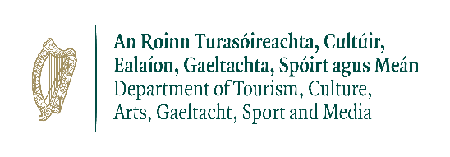

Kilkenny County Council

Decade of Centenaries Grant Scheme 2022

APPLICATION FORM

Please read Guidelines and Criteria before submitting application.

CLOSING DATE: 5pm on Feb 18th 2022

1.0 Applicant Details

Name of Applicant: ______________________________________________________

Organisation (if applicable) ________________________________________________

Name and Title of contact person (for payment purposes):

______________________________________________________________________

Tel: ______________________________ E-Mail_______________________________

Website: (if applicable) __________________________________________________

Address: ______________________________________________________________

______________________________________________________________________

______________________________________________________________________

2.0 Project Details

Title of proposed project

Description of the project (max 200 words) setting out how it commemorates events, people or life in Kilkenny during 1922. Please note it is intended that this description will be used online for promotional purposes and all details, must be as precise as possible:

Location of project (i.e. townland; nearest village/town)

_____________________________________________________________________

Precise Date(s) of project. Please note that these dates will be promoted online.

Commencement date ___________________Completion date ______________________

To which of the following does the Project relate to:
STRAND | NAME | Please tick
1 | Community led commemoration
2 | Respectful non-partisan remembrance
3 | Partitioning of Ireland
4 | Ireland and the wider world
5 | Experiences of women
6 | Establishing a new order
7 | A changing society
8 | Creative thinking and the arts

Please state the type of project, e.g. lecture, exhibition, video etc

___________________________________________________________________________

Please provide details of the target audience and numbers (e.g. children, families, communities etc):

Financial information

COSTS Please provide a detailed breakdown of costs. Where relevant, supply quotes or tenders if available. Please note that receipts (marked paid) are required on completion of the project.
ITEM (e.g., printing, marketing, services, etc) | ESTIMATED COST (€)
TOTAL ESTIMATED COST OF PROJECT

INCOME Please provide a detailed breakdown of all other income sources, if any:
ITEM (e.g. sponsorship, own resources, other funding sources) | ESTIMATED INCOME (€)
TOTAL ESTIMATED INCOME

TOTAL AMOUNT SOUGHT FROM KILKENNY COUNTY COUNCIL: €______________________

If a shortfall occurs, how do you propose to fund the shortfall for the project?

Has this project received or applied for other sources of funding? Yes____ No ____
If yes, please state the source and amount of funding:

Please note that no double funding from Kilkenny County Council is allowed.

PROMOTION
Please indicate how the project will be promoted, i.e. brochures, posters, radio, facebook, Instagram, twitter, newspaper, etc.:

Please provide details of your experience in delivering projects of this nature

APPLICANT STATEMENT
I have completed all relevant sections of this application form and confirm that all information provided is accurate. I am aware of the Council’s Guidelines for assistance.

Name (printed): ______________________________

Signature: ___________________________________ Date: _________________

Please email completed forms to heritage@kilkennycoco.ie 18th Feb 2022 at 5pm

Would you like to be kept informed by email of upcoming heritage events, news and information, including details of events commemorating 1921-1923 in County Kilkenny?
If yes, please enter your email address here: ______________________________________________________________________

