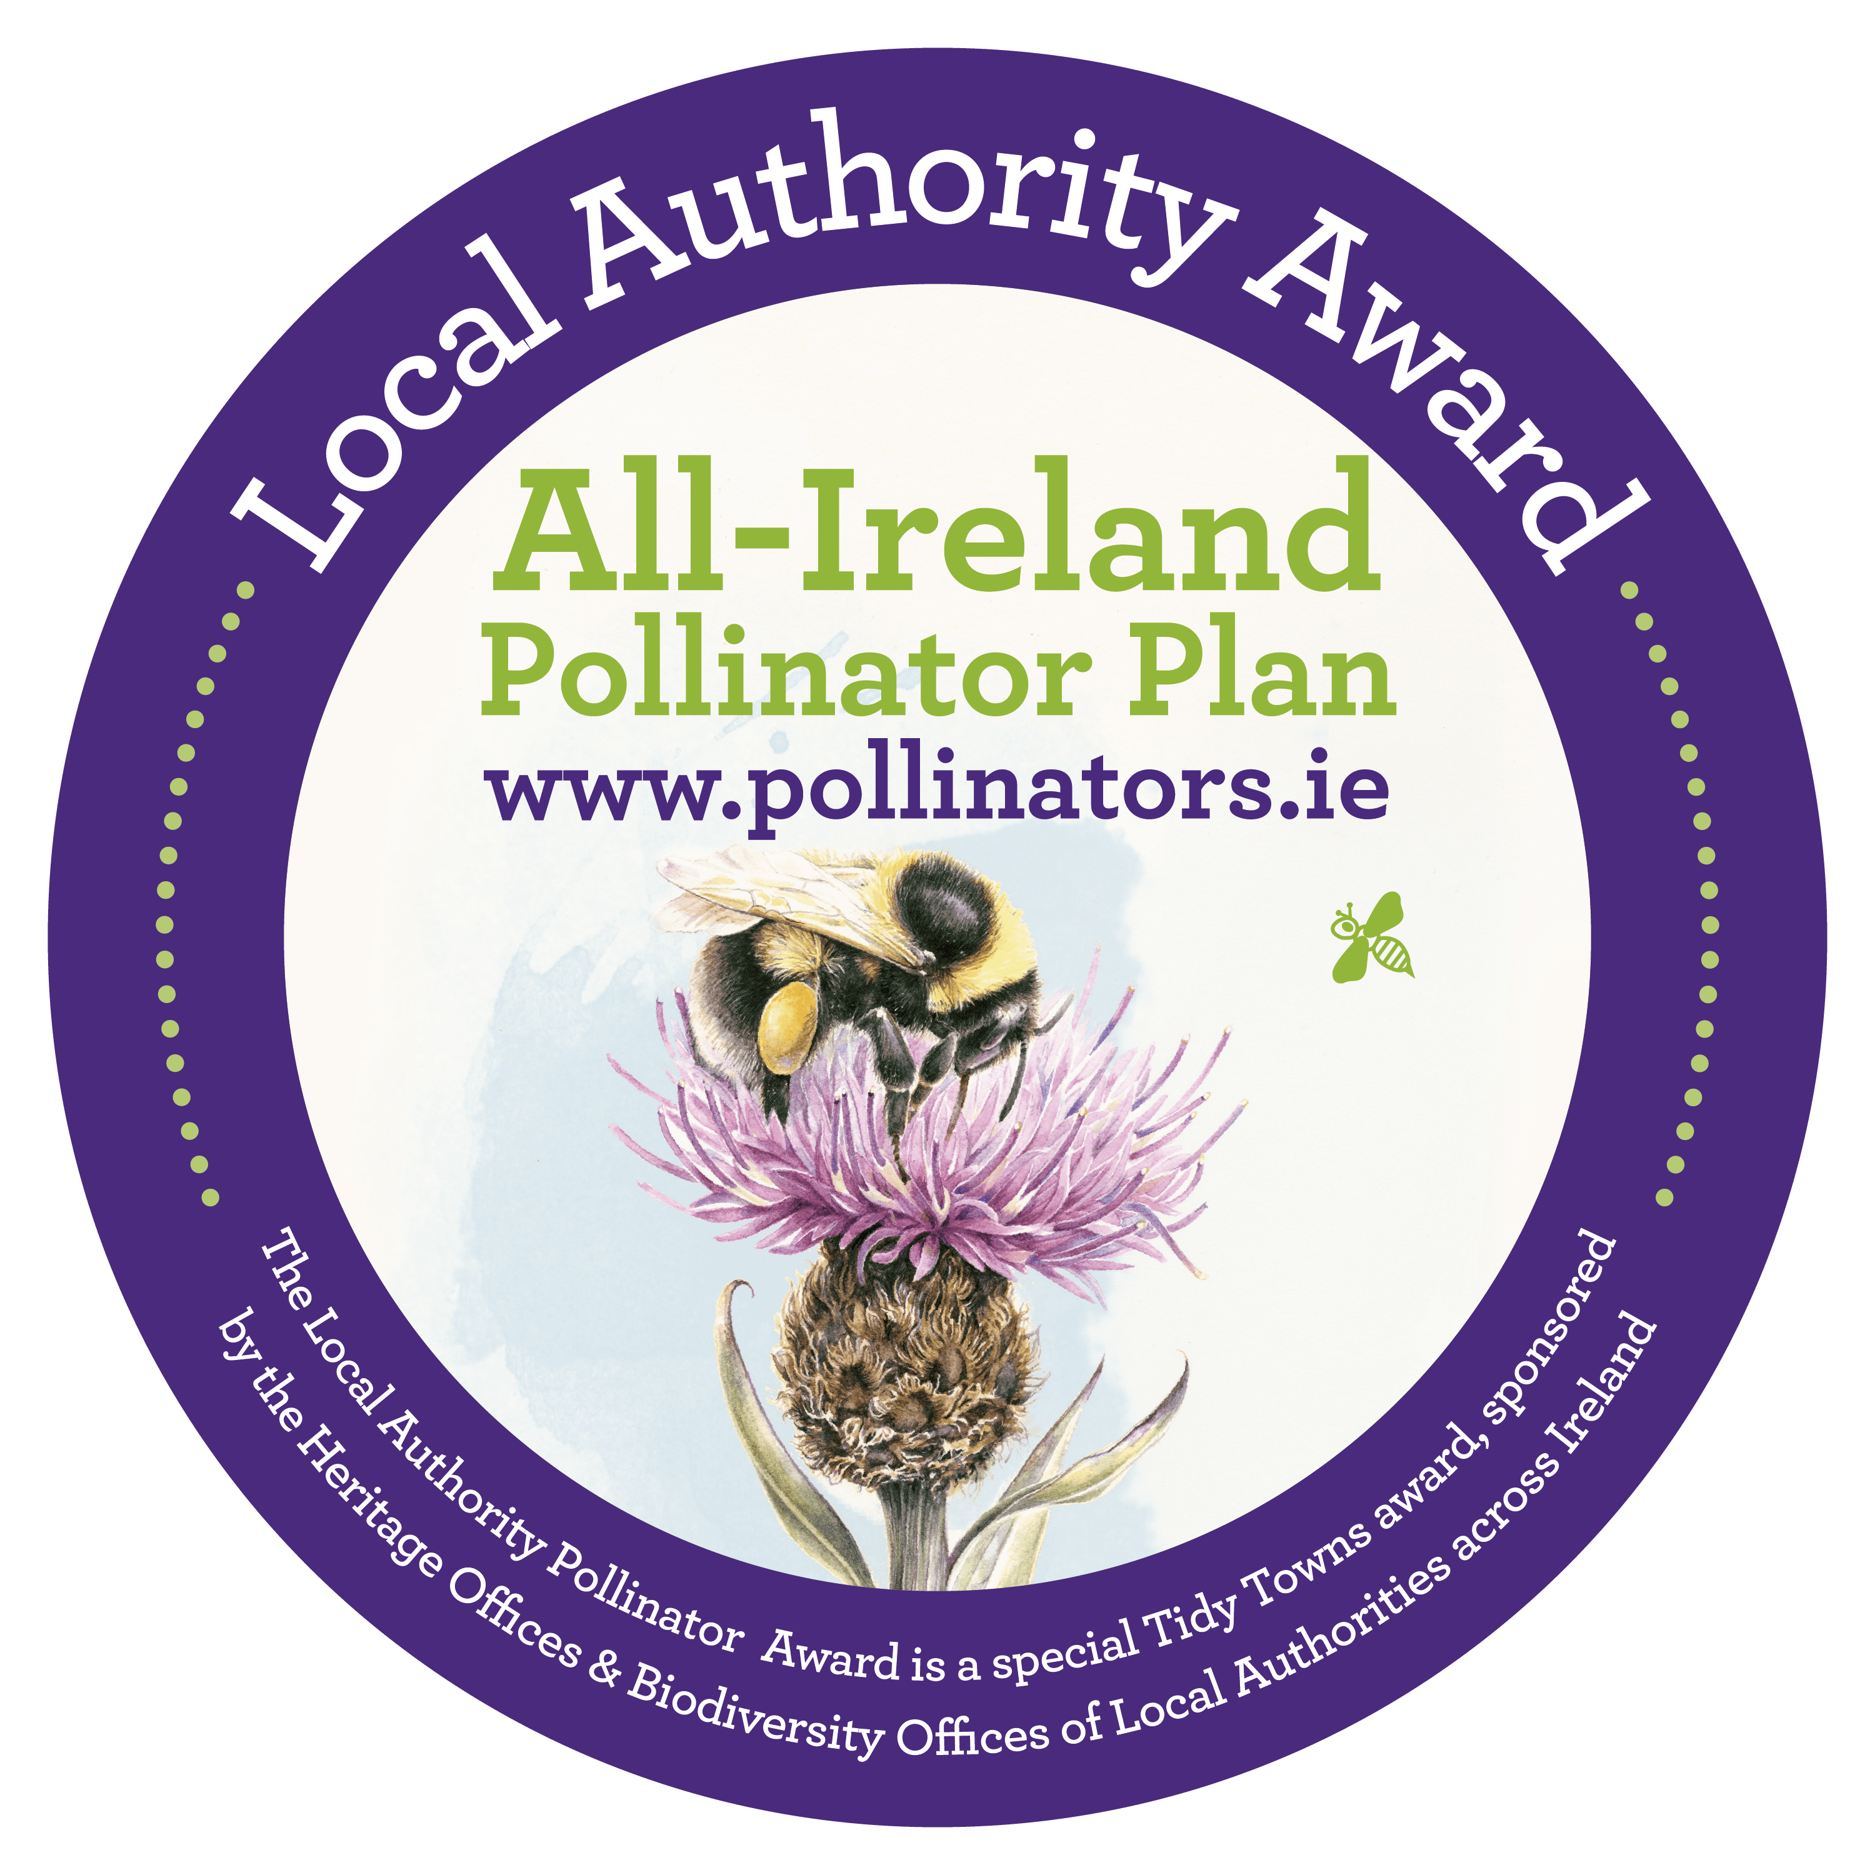
All-Ireland Pollinator Plan: Local Authority Pollinator Award 2022
ENTRY FORM

Name of Tidy Towns Group and County: ...............................................................................................
Tidy Towns Region (as per your national Tidy Towns application form): ...............................................
Tidy Towns Population Category (A-H) (as per your national Tidy Towns application form):……………..
Has your group entered this Pollinator Award before? Yes……………. No…………………..
If Yes, please state which year(s) ................................................................................................................................................................
Nominated contact in Tidy Towns Group: ..............................................................................................
Postal Address: .......................................................................................................................................
.................................................................................................................................................................
Phone number: ................................................. Email:........................................................................
Data Protection
I confirm that my contact details as above may be used in communications relating to the All-Ireland Pollinator Plan Local Authority Award. Any personal information which I provide in this way is not made available to any third parties, save as required by law, and is used by the National Biodiversity Data Centre and Local Authority Heritage Officers/Biodiversity Officers only in line with the purpose for which I provided it. Any personal information which I provide will be treated in accordance with the General Data Protection Regulation.
Please tick your consent to process your data for this application ____

About the Local Authority Pollinator Award & €10,000 prize money
The Local Authority Pollinator Award aims to encourage TidyTowns groups to implement pollinator-friendly actions in their towns and villages as part of the TidyTowns competition. Wild Irish bees, crucial to the pollination of our plants, trees and vegetables, are in decline - this is because we’ve drastically reduced the areas where they can nest and the amount of food our countryside provides for them. The aim of the award is to reverse this trend by encouraging TidyTowns groups to take simple pollinator-friendly measures in their local area. The Local Authority Pollinator Award supports the All-Ireland Pollinator Plan and is sponsored by the Heritage Offices & Biodiversity Offices of Local Authorities across Ireland.
The award categories and prizes are listed below. Awards will be given in all categories subject to satisfactory criteria. For more details see www.TidyTowns.ie or www.pollinators.ie
Category | Large Town or Urban Centre | Village or Small Town
National | €1000 (either population category)
Midlands and East | €1000 | €1000
North West and West | €1000 | €1000
South and Mid-West | €1000 | €1000
South East | €1000 | €1000
Best Newcomer Award | €1000 (either population category)

What types of activities are we looking for?
Local communities can lead the way in driving a better and more sustainable balance for pollinators, and bringing more networks of pollinator-friendly habitats back into our landscape. A guidance document is available, which outlines 24 actions you can take to help pollinators in your local community. Please refer to this when filling out your application form. See http://pollinators.ie/communities/ to download a copy of our ‘Local Communities: Actions to help Pollinators’ guidance document.
A partnership approach to supporting pollinators is important. We encourage you to work with your local authority and other groups in your area. Please provide examples of this in your application form.
On our website, www.pollinators.ie, you will find lots of useful resources, including videos, interviews with winning TidyTowns groups, and presentations, as well as pollinator-friendly planting lists and case studies. You are welcome to screen any of our videos or presentations, as part of your virtual meetings, to help create awareness of the Pollinator Plan. We highly recommend you take the time to look at the resources on www.pollinators.ie. There is a lot of easy to use guidance, including specific advice for other sectors, such as Schools, Gardens, and Businesses, which may give you ideas on how you can get everyone involved in your town or village.
We particularly encourage a whole-town/village approach, rather than isolated project areas – as this is a more effective way to help pollinators and will have a greater positive impact for biodiversity. The evidence-based actions offered by the All-Ireland Pollinator Plan are either zero or low-cost. They range from changing your mowing regime; to planting pollinator-friendly trees and shrubs; and raising awareness. Lots of possible actions are suggested, enabling groups to identify those that are most appropriate for their community. The more of these actions you can do, the more pollinator friendly your local area can become.
You can find 10 top tips for entering the award here https://www.pollinators.ie/wordpress/wp-content/uploads/2019/03/Tips-on-entering-Tidy-Towns-Pollinator-Award.pdf

INSTRUCTIONS TO ENTER
- Please take a ‘whole town/village’ approach, rather than a single project in one area.
- Please fill in the attached application form to let us know in no more than 3,000 words (max 10 A4 pages) how your community is implementing pollinator-friendly actions.
- This application form refers to work undertaken from June 2021-June 2022.
- Only ONE application will be accepted per group, and applications must come from an official Tidy Towns group (as agreed with the National Tidy Town Unit) which has entered the Tidy Towns competition in 2022.
- Questions 1-7 on the application form refer directly to Pollinator-friendly Actions (A-G) outlined in the guidance document, Local Communities: Actions to help pollinators, which can be downloaded from the Pollinator Plan website http://pollinators.ie/communities/ It is advised you refer closely to this document when planning your town’s actions, and filling in this application form. It recognises that groups may not have been able to do as much work as normal, due to COVID 19 restrictions.
- Points are allocated for each question on this application form. All questions must be answered, using this form only.
- Your entry must consist of a single PDF file (comprising the application form, with your photos and map embedded) and this file must be less than 10MB in size.
- Please provide an A4-size map of your town/village marking the locations of each of your pollinator-friendly actions. A hand drawn map is perfectly acceptable. This makes it easier for us to see clearly what pollinator actions you have undertaken throughout your town/village. The map should also be embedded within the application form.
- Please provide photographs to help demonstrate your work. Photos must be captioned, dated and embedded within the application form.
- Email your entry to pollinatoraward@biodiversityireland.ie with “Pollinator Award 2022: Your Town/Village name” in the subject line.
- Please read and tick the Data Protection paragraph above.
Closing Date: Friday 10th June 2022.
Judging the Award: All entries will be assessed by a panel of suitably qualified judges including Local Authority Heritage Officers and Biodiversity Officers, and National Biodiversity Data Centre staff.
All-Ireland Pollinator Plan: Local Authority Pollinator Award 2022
1. One priority of the Pollinator Award is to protect the pollinator-friendly habitats that you already have, and to focus on how you manage them. (See Action 1 in guidelines: Local Communities: Actions to help pollinators). Please provide 3 examples of how you’re doing this, and why you chose these habitats/areas. Mark these 3 areas on your map. (10 points)

2. Provide details of the changes that you made to your mowing regimes to help pollinators (Actions 2-4). Please provide details of mowing locations, and changes in mowing regimes, and mark the areas on your map). (15 points)

3. Provide details of any pollinator-friendly planting that you provided and manage (e.g. perennial plants, propagation, native seed gathered locally) (Actions 5-11). Please provide the names of all pollinator-friendly plants used, and mark these areas on your map.
(10 points)

4. Provide details of nesting habitats that you provided for wild pollinators, and mark these areas on your map. (Actions 12-15 explain how to create bare earth for mining bees as well as holes in wood for cavity-nesting bees). Please refer to our ‘How to guide: Creating wild pollinator nesting habitat’ at http://pollinators.ie/resources/ (10 points)

5. Provide details of how you omitted or reduced the use of pesticides. Please include details of the quantities and size of areas as appropriate. (Actions 16-17) (10 points)

6. Provide details of how you raised public awareness of pollinators in your local area, and how you worked in partnership with your local authority and other groups. Action 18-21). If your group uses social media please include links to Facebook pages or Twitter handles. (10 points)

7. Are you measuring the impact of your work (Action 22-23)?
7a. Have you added your pollinator-friendly sites to the online mapping system called ‘Actions for Pollinators’? This mapping system is very important to help us to track the build-up of food and shelter for pollinators across the island (see https://pollinators.biodiversityireland.ie/) (5 points)
Yes……….. No………….

7b. Are you taking part in the National Biodiversity Data Centre’s Bumblebee Monitoring Scheme? (see http://www.biodiversityireland.ie/record-biodiversity/surveys/). (5 points)

Yes………. No………….

8. What are your next THREE priorities or future projects for pollinators for the coming year?
(5 points)

9. Please provide captioned photographs throughout your application which illustrate the work that you have done
(10 points)
Photos included: ……………..

10. Please provide an A4 size map of your town/village, highlighting the locations of all your pollinator-friendly actions. This makes it easier for us to see clearly what pollinator actions you have undertaken throughout your town/village. (10 points)

Map included: ……………………

TidyTowns Terms and Conditions apply.

