Kilkenny County Swift Survey 2021
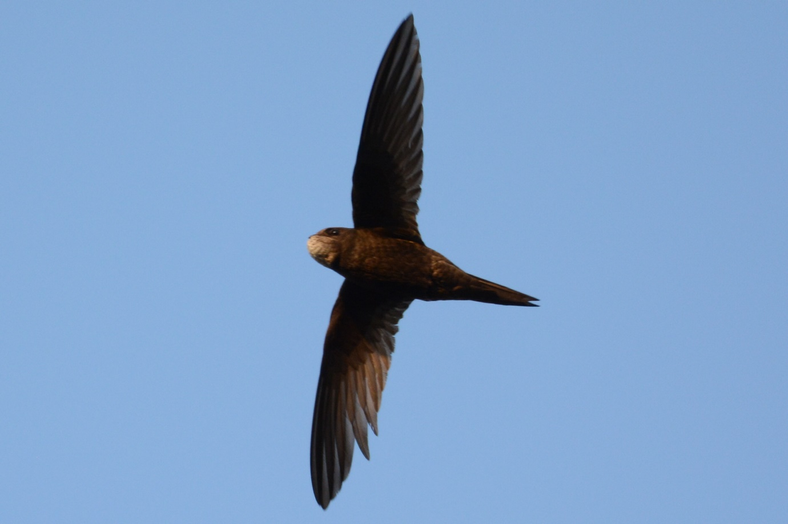
Prepared by: Stephen Bolger, Brian Caffrey and Ricky Whelan.
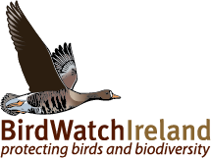

A project funded by
Commissioned by the Heritage Office of Kilkenny County Council, co-funded under the National Biodiversity Action Plan by the Department of Housing, Local Government and Heritage, and the Heritage Office of Kilkenny County Council
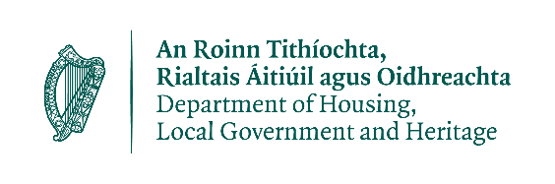

Executive Summary

Swifts are a small species of bird that visits Ireland to breed in spring, arriving in early May and departing as soon as the chicks are fledged usually by early August. They are insectivorous and live life largely in flight and are adapted to feeding, drinking, gathering nest material and mating on the wing. They nest in cavities in masonry and on gaps in the roof spaces of old buildings gaining access through broken fascia and soffit or under roof tiles. They are site faithful and return to the same nest site year on year. Modern buildings are designed and built to be extremely energy efficient, which leave little nesting opportunities for Swifts. The loss of existing nest sites coupled with other wider environmental issues such as climate change has resulted in large declines in Swift populations in Ireland. It is with this in mind that many local authorities including Kilkenny County Council have been motivated to carry out a county Swift survey to establish the distribution and density of nesting Swifts in the county and to help conserve this iconic urban species into the future.
The Kilkenny Swift Survey 2021 was commissioned by the Heritage Office of Kilkenny County Council. It was co-funded under the National Biodiversity Action Plan by the Department of Housing, Local Government and Heritage, and Kilkenny County Council. The effort has been very successful in achieving the aims of the project. The survey work commenced at the beginning of June following a delayed start due to restrictions from Covid 19. Surveying was carried out as planned, adhering to HSE guidelines on Covid 19 (e.g. social distancing). However, the community engagement aspects of the project had to be altered to adhere to the restrictions. Local contacts were able to assist the Swift surveyors in identifying areas previously occupied by swifts. The main aspects of the project (surveying, engagement, data analysis and reporting) were carried out by BirdWatch Ireland’s Swift Surveyor Stephen Bolger and by the members of the BirdWatch Ireland Kilkenny Branch. Publicity including project promotion/ awareness raising and media engagement were carried out by Project Officer Ricky Whelan and Brian Caffrey of BirdWatch Ireland whilst Dearbhala Ledwidge, Heritage Officer Kilkenny County Council, co-ordinated all local media (radio, newspaper and social media) and managed the local citizen science element of the project.
Overall, it took more than 45 days survey work to adequately survey the 50 towns and villages in the county. A total of 199 Swift nest sites were confirmed during the fieldwork phase. These nest sites were distributed throughout 13 localities with Swifts observed in an additional 3 localities but with no nest sites confirmed. The colonies ranged in size from 1 to 21 nest sites, distributed across 40 individual structures/buildings. Swift nest sites were found in a host of building types with a high proportion located in residential properties in private ownership (39%). Public buildings accounted for 29% of the nest sites confirmed; church/religious buildings host 11%; small businesses account for 10%; castle/heritage sites, other and industrial structures account for 6%; 5% and 1% of confirmed nest sites respectively. The key Swift populations were found to exist in Kilkenny City (52), Callan (12), Thomastown (27), Gowran (14) and Graiguenamanagh (12) respectively. The most vulnerable site is Inistioge with only 2 breeding pair of Swift remaining.
Looking at the distribution of Swifts nest sites on a county scale, the main concentrations are found in Kilkenny City. The River Nore and the mosaic of smaller Rivers further south-east such as the Kings River in Callan provide all the insect prey Swifts required to rear young and good populations can also be found here, important but also vulnerable colonies were found in Thomastown and also in Graiguenamagh.

There are 51 buildings across 13 localities that house all of Kilkenny’s Swifts, these should form the focus off future conservation efforts through working with owners, residents and managers to ensure Swifts can be accommodated now and into the future. The next priority is to grow the opportunities for nesting Swifts in the county which can act to increase the population and spread the risk of colony losses where local populations are isolated to single or small numbers of structures.
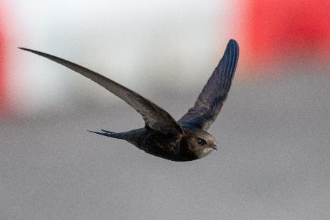
To achieve this, it is important to secure local buy-in and support from local communities to champion their local Swifts and to carry out the required actions to protect them into the future. However, this can’t be done without support from experts and the local authority and this report offers recommendations at both a county and local level to help conserve Swifts. In some towns and villages, individuals and groups are already doing excellent work for Swifts, but more work will be needed at a wider scale to ensure a future for Swifts in county Leitrim. The local authority through its Heritage, Planning, Engineering, Asset Management, and other relevant staff can also play a key role in conserving Swifts through their everyday work.
Swift in flight. photo: Piotr Rak

